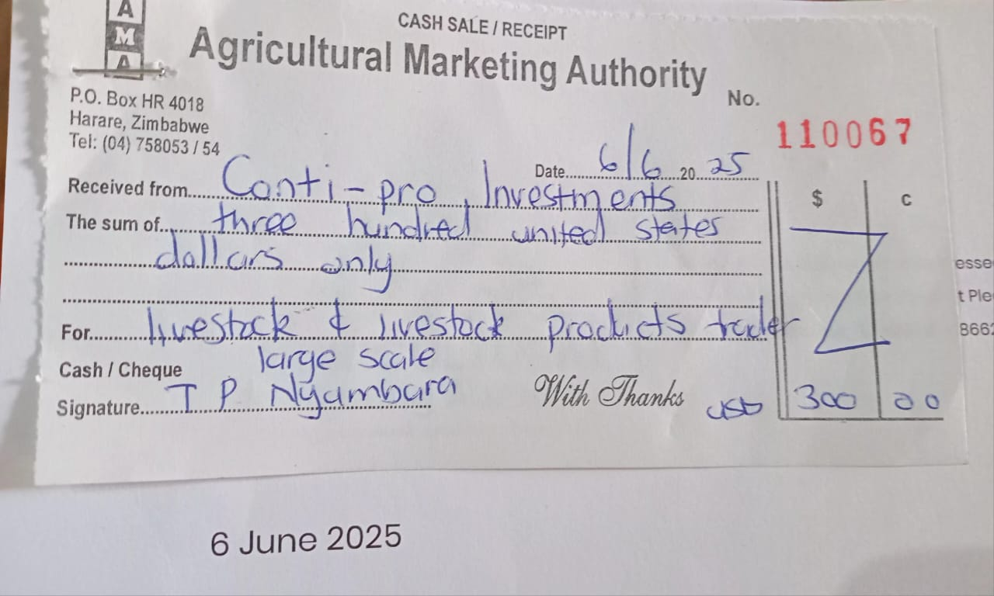

**Cash POP , ContiPro Investments , AMA Large Scale Livestock & Livestock Products Traders**

