How to capture farmers using AMA portal
Login in
https://ama.co.zw/portal/admin/officer-login.php
username = email address
password = 123456 please change the password (this is the default password)
Adding farmers
The procedure is divided into 2 phases:
- Adding farmer to the database
- Registering farmers for the particular season (subscription)
PHASE 1
Adding farmers
We already have farmers in our database, so it is prudent to search from available farmers to see if the farmer is already in our database.
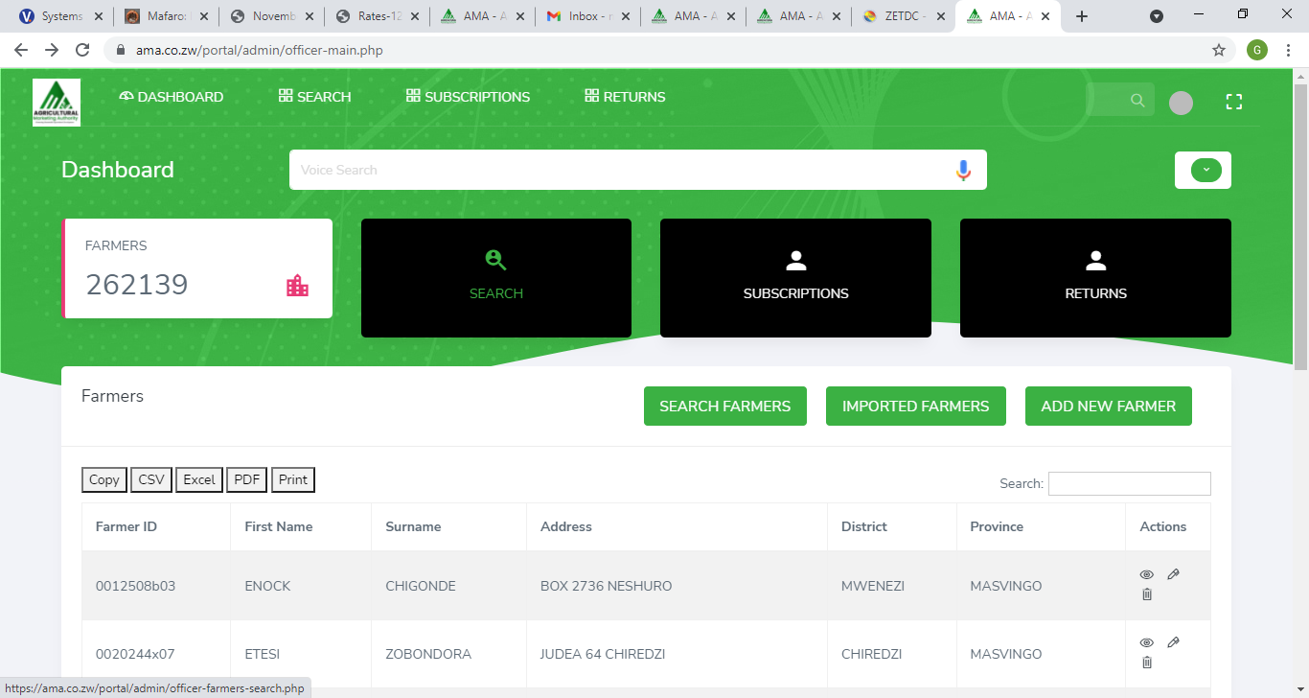

User search farmers
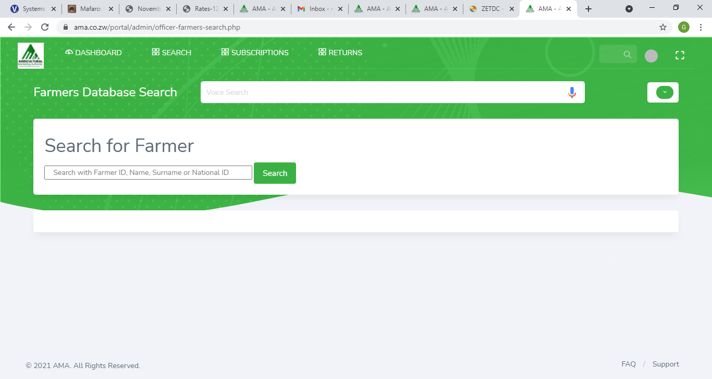
Search using name or id number(without spaces , without dash)
If farmer is available please go to Phase 2
If the farmer is not available then use the following steps
go to add new farmer
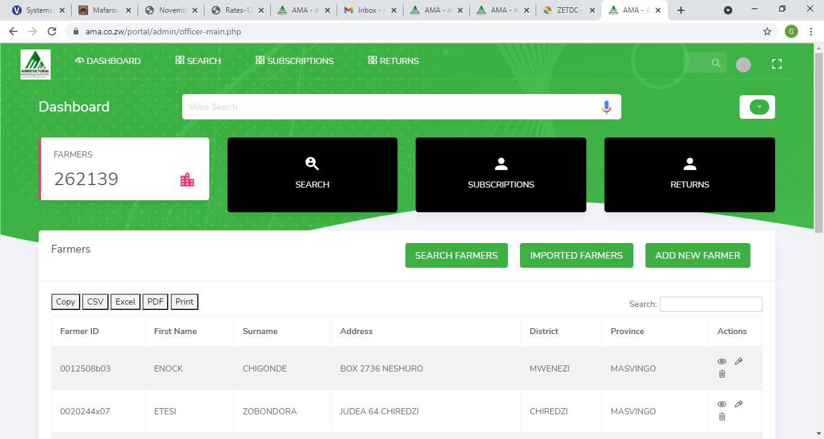

Complete the form
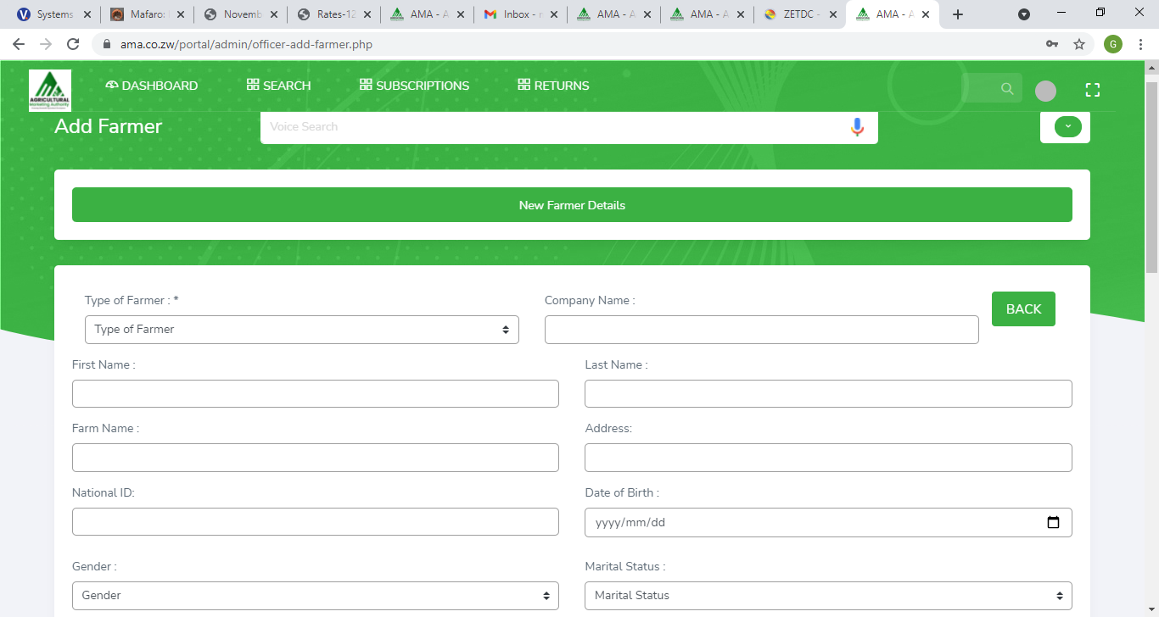
Click on add to complete adding the farmer to the database
Phase 2
Phase 2- Registering the farmer for the season(subscription)
After adding the farmer to the database then next phase is registering for the season
Search the added farmer
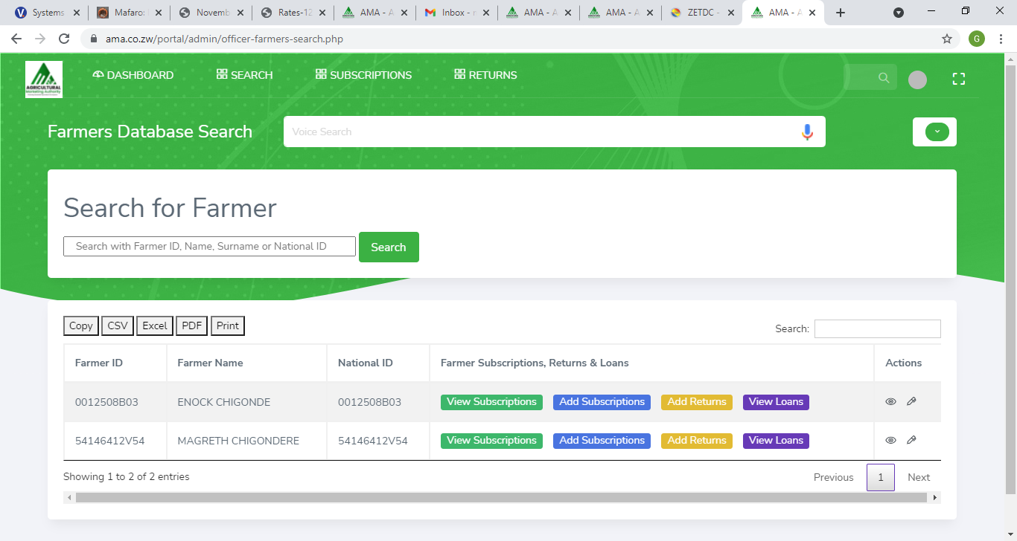
When found
Click on add subscription
Choose the correct category. The category are as follows
- Grains and Oil seeds
- Horticulture
- Macadamia
- Livestock
- Cotton
- Wheat
The default is Grains and Oil Seed(make sure you select the correct category)
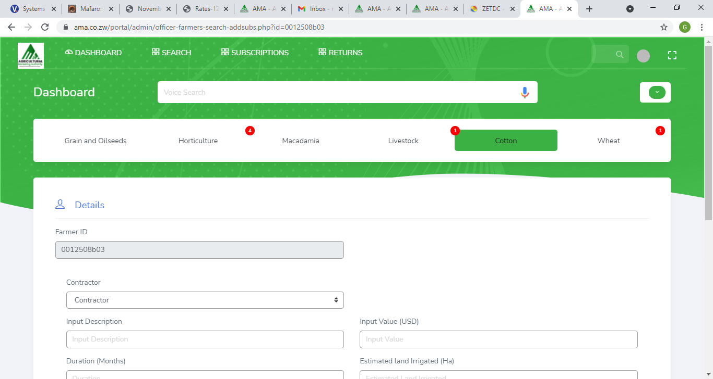
Current category is seen by the dark green color as illustrated above
Select contractor from the dropdown menu
Complete the form
Click on subscribe
After this the progress of registering the farmer for the current season is complete. Farmer details are only captured once. Farmer is register for the season through subscription to a particular category per season.
Loans
Once a farmer is registered for a particular season through subscription and that registration is done by a contractor that automatically become a loan because the farmer is indebted to the contractor who acts as the financier.
After successfully searching for a farmer click on view loans
After clicking on view loans if there is an available loan, you can view the amount, the lender and the status as shown below
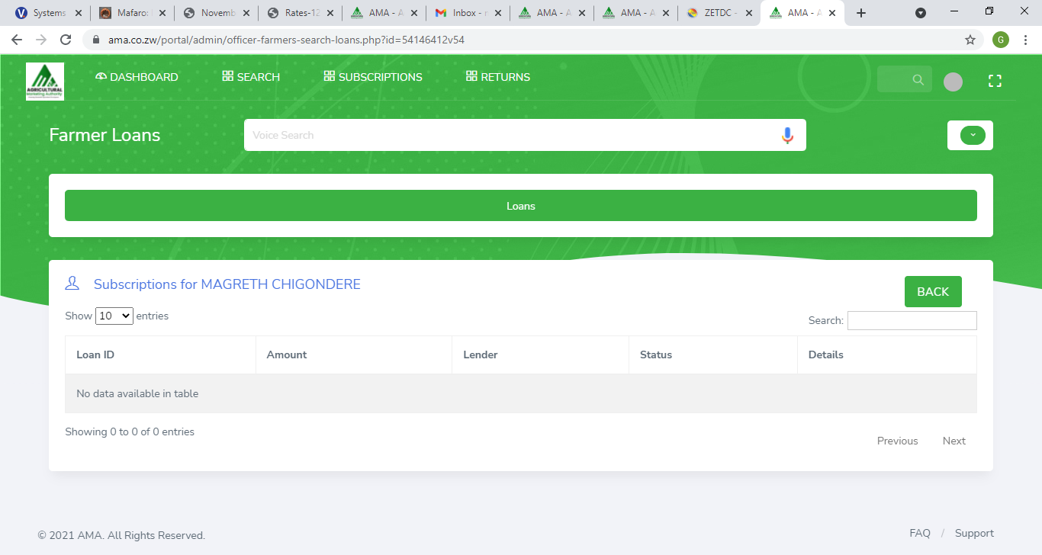
If blank the farmer is not under any contract
Returns
After marketing season every farmer is expected to submit returns online or through the contractor
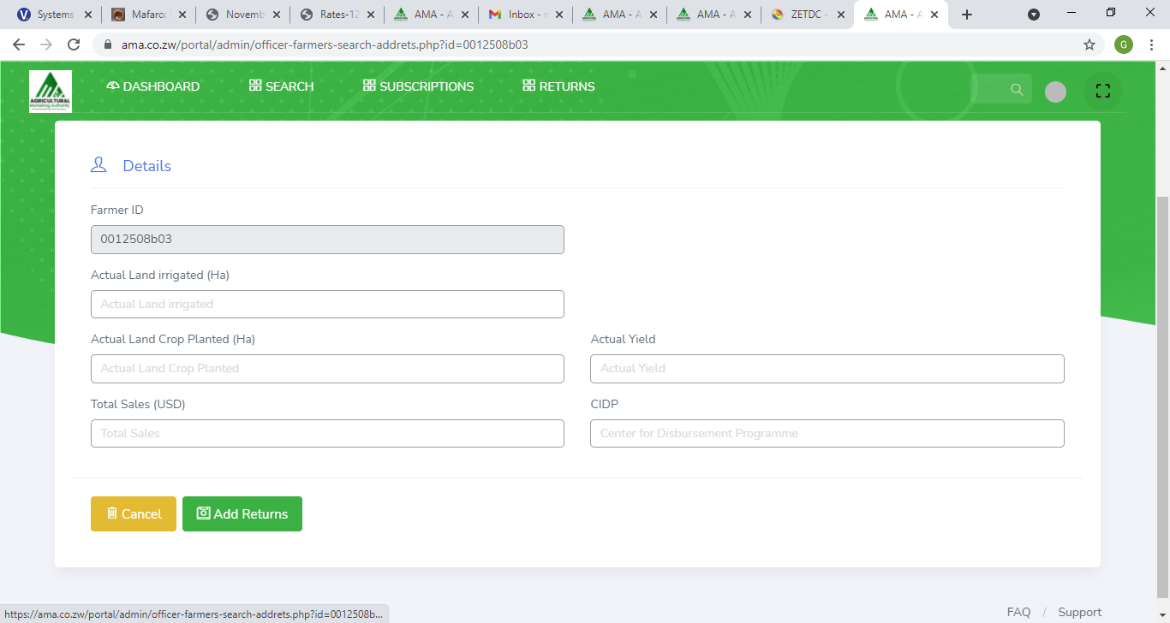

After viewing the farmer you should be able to add returns for the farmer. Returns are tied to the subscription or registration done during the production season. One cannot submit returns without a valid subscription or registration for the season
NB returns are tied to the subscription made during production.

